Smart Companion


Sponsor
Insert the link to the project sponsor here

Project Summary
The goal is to make the world a little less stressed. Our smart companion has to make a difference in the life of people struggling with anxiety, calm them down and help them control their mood.
The project requirements are:
- Stay sustainable trough-out the project and the product itself, as well as the packaging
- Our marketing has to comply with the values of gender and racial equality
- Don't cross ethical lines
- create a good user experience and relationship, because we are a mental health company
- Comply with the following EU Directives:
  - Electromagnetic Compatibility Directive (EMCD);
  - Low Voltage Directive (LVD);
  - Machinery Directive (MD);
  - Radio Equipment Directive (RED);
  - Restriction of Hazardous Substances in Electrical and Electronic Equipment Directive (ROHS);
- Mandatory adoption and use of the International System of Units (The NIST International Guide for the use of the International System of Units)
- Use open source software and technologies.

Participants
Institution: Instituto Superior de Engenharia do Porto
Team N. 5:
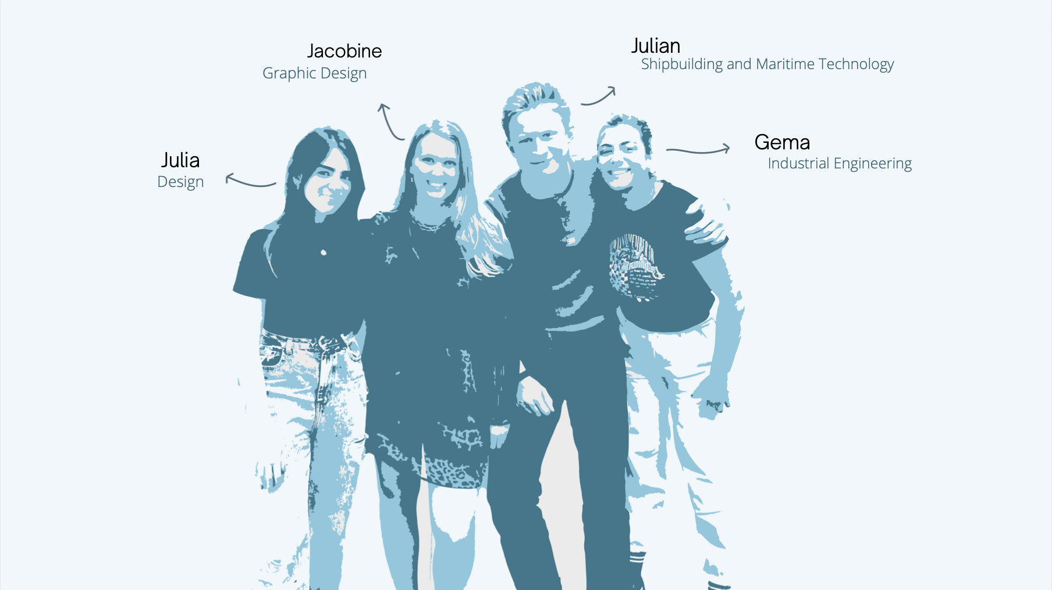
Team DSTRS
Students:
- Jacobine Camps
- Gema Romera Cifuentes
- Júlia Maria Lopes do Nascimento
- Julian Alexander Bode
Panel of Supervisors:
- Abel Duarte (ajd 'at' isep 'dot' ipp 'dot' pt)
- Jorge Justo (jfj 'at' isep 'dot' ipp 'dot' pt)
- Maria Benedita Malheiro (mbm 'at' isep 'dot' ipp 'dot' pt)
- Maria Cristina Ribeiro (mcr 'at' isep 'dot' ipp 'dot' pt)
- Manuel Silva (mss 'at' isep 'dot' ipp 'dot' pt)
- Paulo Ferreira (pdf 'at' isep 'dot' ipp 'dot' pt)
- Pedro Barbosa Guedes (pbg 'at' isep 'dot' ipp 'dot' pt)
Client:
- Client Name, email, etc.

Contents
Project Planning: Deadlines, Tasks, Gantt chart, Task allocation
Logbook: Weekly Report, Meetings, Activities
Report: Report
Deliverables: Links to all deliverables

Contacts
- Student 1 Jacobine Camps, 1212300@isep.ipp.pt, jacobine.camps@hotmail.com, Facebook: Jacobine Camps, instagram: @Jacobine_camps or @cioccodesigns, +32475273489
- Student 2 Gema Romera Cifuentes, 1210451@isep.ipp.pt, geroci00@gmail.com Facebook: Gema Romera Cifuentes, Instagram: @geroci00, etc.
- Student 3 Name, username@mailserver, facebook, twitter, etc.
- Student 4 Julian Alexander Bode, 1212306@isep.ipp.pt, julian.a.bode@student.fh-kiel.de

Utilities
- DokuWiki Syntax
- Videos on how to use DokuWiki

Acknowledgements
- Sponsor (sponsor)
- Eng.º Vítor Costa Cerqueira, DEE, ISEP (wiki installation and management)
- Prof. João Correia Lopes, DEI, FEUP (wiki template)
— EPS@ISEP Wiki Template 2012-01-15 15:35

